THERMODYNAMICS SHORT NOTES
- Different applications needing cooling
- Any change, Natural or man-made, must obey the laws of thermodynamics
- Second law: directionality and puts limits on the conversion of energy from one form to another
- 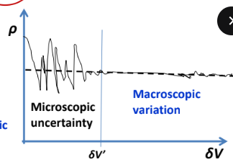
- A system is defined as a fixed mass and identity of matter on which attention is focussed. The rest of the universe, which lies outside the system, is called the surrounding.
- 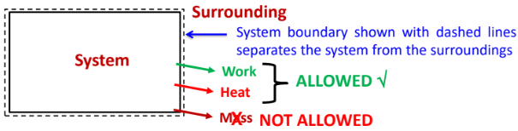
System boundary can be real or imaginary, and it’s size and volume can change with time
- A control volume is a fixed volume in space on which attention is focussed
- 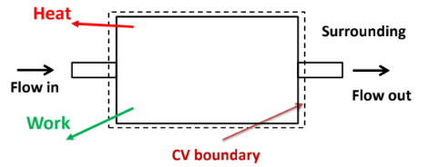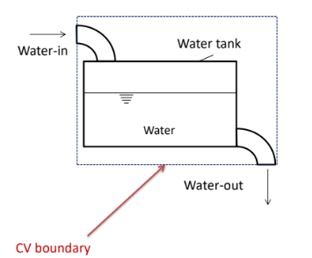
- 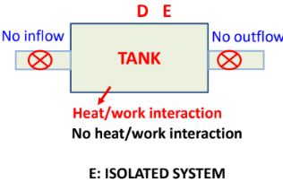
- Any measurable and observable macroscopic characteristic of a substance is called a property.
- Intensive property: Independent of mass of the system (pressure, temperature, density)
- Extensive property: Dependent on the size/mass of the system (volume, potential energy, kinetic energy)
- Specific property: Extensive property per mass
- A state represents the collection of all properties of a system when the system is in thermodynamic equilibrium. All property values throughout the system should be uniform. At least for a moment they should be invariant of time. A state can be represented as a point in a thermodynamic coordinate system. Hence, the property is called a point function or state variable.
- Thermodynamic equilibrium is ensured by the attainment of mechanical equilibrium (no force imbalance between the system and the surroundings), thermal equilibrium (no temperature difference between the system and the surroundings) and chemical equilibrium (same chemical composition and aggregation).
- Change of state occurs when any property of the system changes its value. Path is the locus of all the intermediate states that the system passes through when there is a change of state. Process is a sequence of states by which the change of state takes place in a particular path – mathematical relation. Cyclic process in which the system changes its state more than once and finally reaches the same initial state – there is no net change in any property during a cyclic process. Quasi-static process is a slow process in which the intermediate states are well accounted. The process has several intermediate “equilibrium” states. Properties are defined only in quasi-static processes. Energy transfers can be calculated only when the process is quasistatic.
- Properties are path independent. Properties are unique to a state. The values are the same at a point (state) irrespective of the thermodynamic path taken to reach the present state from a previous state. They are called exact differentials. For example, a change in property is written as dΦ.
- The total differential of this function is defined as $ⅆz={\left(\frac{∂z}{∂x}\right)}_{y}ⅆx+{\left(\frac{∂z}{∂y}\right)}_{x}^{}dy$.Any differential of this form is exact In general, a differential dz expressed as dz=M(x,y)dx+N(x,y)dy. Condition for exactness is ${∂M}/{∂y}={∂N}/{∂x}$. In this case dz is exact and state function. dz is not total differential and it is inexact, z is not a point or state function and represented as $δz$.
- Manometer/Bourdon gauge measure pressure w.r.t surrounding pressure.
- Barometer measures the absolute pressure (Atmospheric pressure = ρgH)
- The thermodynamic definition of work, on the other hand, represents an energy interaction between the system and the surroundings. Work is said to be done by a system, during a given operation, if the sole effect, external to the system could be reduced to the raising of weight through a distance.
- Since work is an energy interaction between the system and the surrounding, there must be a donor and a receiver. When a system transfers energy in the form of work, it does positive work. At the same time, the surroundings will do an equal amount of negative work.
- If all components are included in the system, there is no work interaction.
- A very important aspect of work interaction is that the process carried out by the system must be resisted by the surroundings. If the surroundings do not offer any resistance, then the work done by the system will become zero. There is merely a conversion of potential energy into kinetic energy but no energy crosses the system boundary.
- 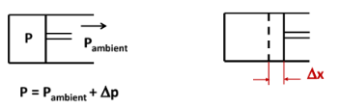
There are three separate objects to consider: Gas enclosed inside the cylinder, Piston, Ambient air
Work interaction between the gas and the surroundings: W1 = P * A * Δ x
Work done by the piston on the surrounding + work done by the gas on the piston
W2 = (P _{ambient} – P)*A* Δ x
Work interaction between atmospheric air and surroundings: W3 = -P _{ambient} *A* Δ x

- When 2 bodies at different temperatures are brought into contact, after some time they attain a common temperature – they are said to be in thermal equilibrium.
- Temperature may be understood as that property which determines whether two systems are in thermal equilibrium or not.
- Thermometer is a device used to measure the temperature.
- The length of a copper rod changes when it is heated or cooled. The change in length is proportional to its temperature change.
- Celsius (°C), Fahrenheit (°F), Rankine (°R), Kelvin (K) • °F = 1.8 °C + 32 • °R = °F + 459.67 • °R = 1.8 K • K = °C + 273.15 • °R, K ≥ 0
- Triple point of water (0.01°C). At 611.2 Pa and 0.01°C, water exits at its three phases – solid, liquid and vapor.
- If X is thermometric property at any temperature T and X_{t} is the value of the property measured at triple point of water, then the temperature T is evaluated as T = 273.16 X / X_{t}.
- Heat is energy interaction between a system and surroundings that occurs solely due to temperature difference between the two. In phase change situations, the heat transferred to the system is utilized for heat required for phase change and temperature remains constant in those cases. Heat is energy in transit. Heat cannot be stored. Just like work, heat interaction between a system and surroundings is only defined at the system boundary. Heat transfer from surroundings to a system is considered positive. Similarly, if there is an increase in temperature that may not have resulted from heat transfer (rubbing of palms) it may result due to work transfer (movement against friction).
- Modes of heat transfer
1. Conduction 𝑄= −𝑘𝐴 𝑑𝑇/𝑑𝑥
2. Convection 𝑄=ℎ𝐴(𝑇1 − 𝑇2)
3. Radiation 𝑄=𝜎𝜖𝐴(𝑇1⁴ − 𝑇2⁴)
4. Units of heat transfer = W (= J/s)
5. 𝑄 is heat transfer rate
- First law of thermodynamics: Conversion of heat to work / work to heat
- In general for a cyclic process: Σ𝑸 −Σ 𝑾 =0
- For a finite process (non-cyclic) Q – W = ΔE (E is stored energy, Stored energy (E) is sum of different forms of energy: Kinetic energy, Potential energy, electrical energy, magnetic energy, internal energy)
- We now define a new property called enthalpy H as follows H = U + PV
- The first law for a non-cyclic process can now be written as:𝑸 = 𝒅𝑯 − 𝑽 𝒅P
- 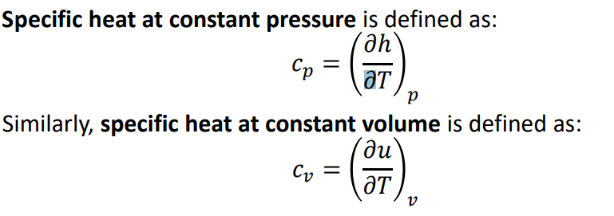
- ‘Pure substance’ is a substance which has uniform composition and chemical aggregation throughout the process under consideration.
- Gibbs Phase Rule F:=c-ϕ +2 where F is degrees of freedom, c is number of components and ϕ is number of phases
- Two-property rule : The state of a pure substance of given mass can be specified in terms of two independent properties, in the absence of effects due to gravity, motion, electricity, magnetism, elastic deformation, etc.
- 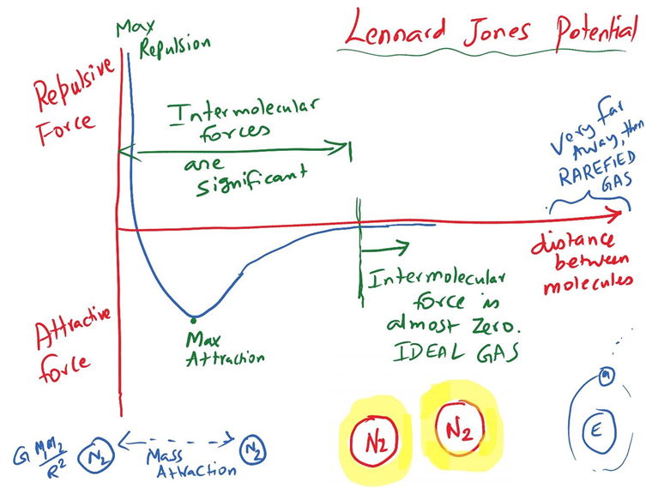
- Boyle’s Law: At constant temperature, the volume of a given mass of gas is inversely proportional to its pressure
- Charles’ law: At constant pressure, the volume of a given mass of gas is directly proportional to its temperature.
- Ideal gas equation: 𝑝V=n $\overline{R}$T or 𝑝V=𝑚𝑅T where $\overline{R}/M$=R (M is molecular weight in kg/kmol) and $\overline{R}=8.314\frac{J}{kmol}K$
- In general for any pure substance internal energy (U) depends on two properties specifying the state. For low density gases it primarily depends on depends on temperature and much less on pressure or volume 𝑼=𝑼(𝑻) or u=u(T) (Proved by Joule’s experiments)
- Internal energy of a gas depends on Translational KE, Rotational KE and Vibrational KE of molecules. 𝑼=1/𝟐 𝒌_{𝑩}𝑻, k_{B} – Boltzmann Constant = 1.38 X 10⁻²⁶ kJ/K , 𝒌_{𝑩}= 𝑹/𝑵_{𝑨,} 𝑵_{𝑨}– Avogadro Number = 6.023 X 10²⁶ molecules/kmol
- Total degrees of freedom – D , Internal energy per molecule - 𝑼=1/𝟐 𝒌_{𝑩}𝑻D , Molar internal energy $\overline{U}$(internal energy per kmol of gas) – D/2$\overline{R}T$ , Molar enthalpy $\overline{ H}$ – (D+2)/2$\overline{R}T$
- 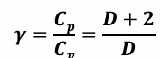 ,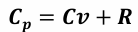
- Number of degrees of freedom may change with temperature as vibrational mode gets excited at higher temperature.
- For perfect gases, specific heats are constant, so the enthalpy (H) and internal energy are (U) are linear functions of temperature.
- , , 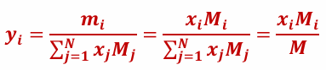 , 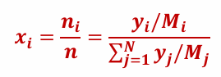
- Dalton’s law of partial pressure: Each component in a mixture can be assumed to exert partial pressure at the mixture temperature and volume such that sum of the all partial pressures is equal to the total pressure of the mixture.
- Amagat’s law of partial volume: Each component in a mixture can be assumed to occupy partial volume at the mixture pressure and temperature such that sum of the all partial volumes is equal to the total volume of the mixture.
- Thus specific properties of an ideal gas mixture can be expressed as product of mass fraction and specific properties of each species summed over all species. Similarly molar properties of a mixture can be expressed as product of mole fraction and the molar property of the component species summed over all species of the mixture.
- 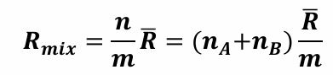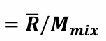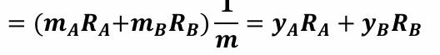
- A certain amount of liquid is contained in a container maintained at pressure P and temperature T. Molecules in the liquid possess kinetic energy and are in constant motion. Those molecules near to the liquid surface can "escape" (evaporate) into the vapour phase above the liquid. As time passes, there will be more and more molecules from the liquid phase that enters the vapour phase. Some of these molecules in the vapour phase will collide with one another, and some will "re-enter" (condense) into the liquid phase. Eventually the vapour space above the liquid will become saturated with molecules, that the tendency of molecules to escape (vaporise) is just balanced by the tendency for them to be recaptured (condensed). At this point, we say that an equilibrium condition had been reached between the vapour phase and the liquid phase at the given pressure P and temperature T. The pressure exerted by the molecules in the vapour phase on the walls of the container is known as the equilibrium vapour pressure (PVP) of the liquid at temperature T. The equilibrium vapour pressure of the liquid is a strong function of temperature, and as the temperature increases the equilibrium vapour pressure increases. The temperature at which the equilibrium vapour pressure exerted by the liquid equals the atmospheric pressure is the normal boiling point of the liquid. When the pressure is increased, it will be more difficult for the liquid molecules to escape into the vapour phase. Thus, the boiling point of a liquid increases with pressure; and the reverse is true for lower pressure.

- 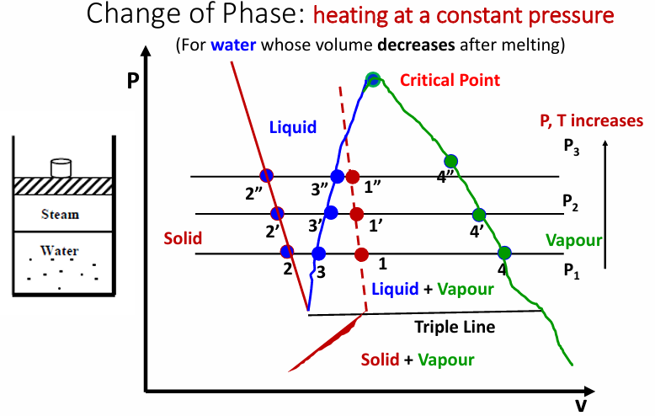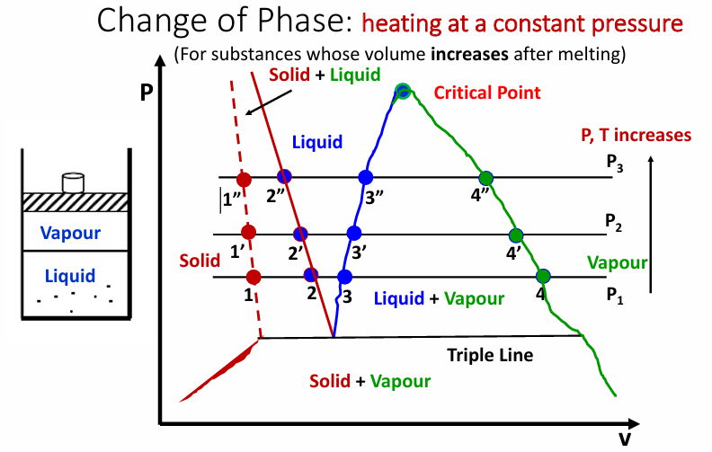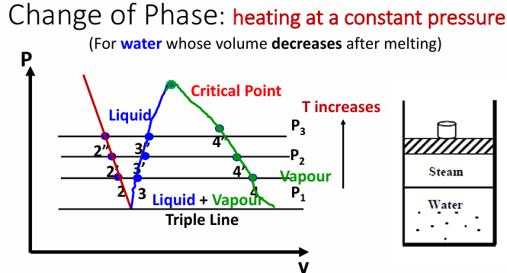
A critical point, also called a critical state, specifies the conditions (temperature, pressure) above which distinct liquid and vapour phases cease to exist. Water: 647 K (374 °C) and 22.064 MPa.
- 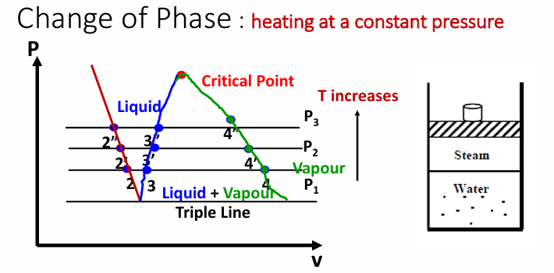
Triple point of a substance is the temperature and pressure at which three phases (gas, liquid, and solid) of that substance may coexist in thermodynamic equilibrium. 7 Water: 273.16 K, 611.66 Pa
- 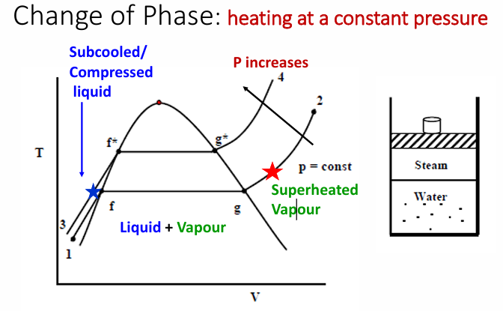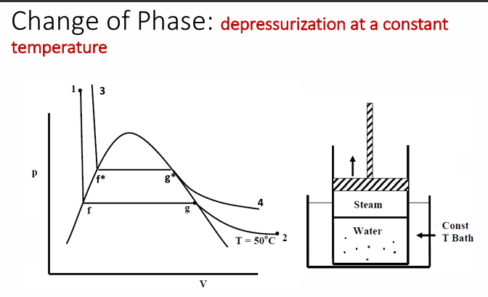
- 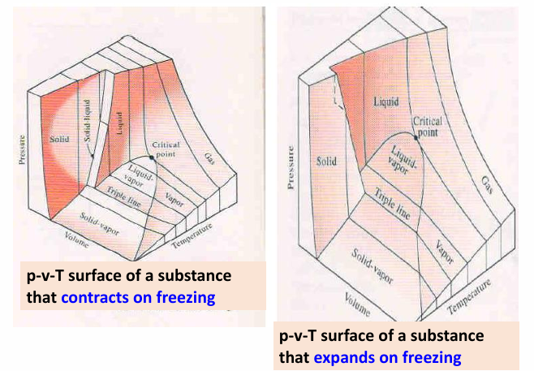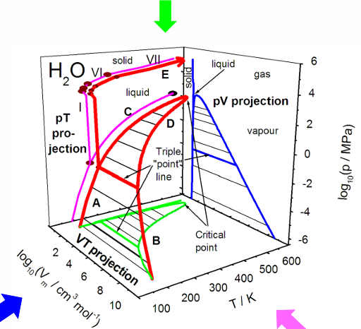
- 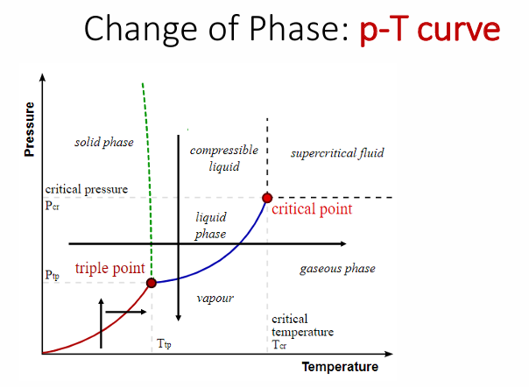
- 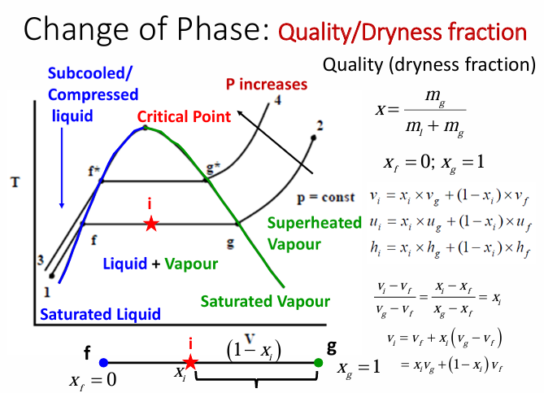
Use interpolation suitably to get properties like u, v, h as a function of (p, T)
If the condition pertains to sub-cooled liquid, then use temperature-based saturation table and write h=u+pv_{f .}At a temperature T_{f} ). This value of enthalpy will usually be very close to h_{f}.
- For CV the work interaction does not include displacement work. Includes other forms of work, ‘external work’: shaft work, electrical work, magnetic work, etc.
- 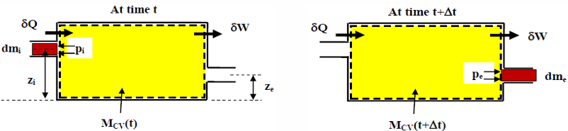
- Fluid mass (MCV(t) + dmi) is identified as system at time t, Fluid mass (MCV(t+ Δt) + dme) is identified as system at time (t +Δt). MCV(t) and MCV(t+Δt): fluid masses that occupy the control volume at time t and (t+Δt) respectively. dmi and dme are the masses that enter into and exit from the CV respectively over a time interval Δt. 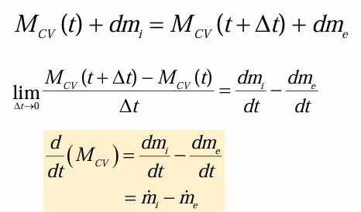
- For steady state, no time dependence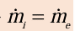
- δQ is the heat added to the system over a time interval Δt, δW is the work done by the system over a time interval Δt. First law applied to the considered system Heat added to the system – Work done by the system = Change in total energy of the system
Flow work at inlet is negative: surrounding pushes the fluid in. Flow work at exit is positive: exiting fluid pushes the surrounding outward.
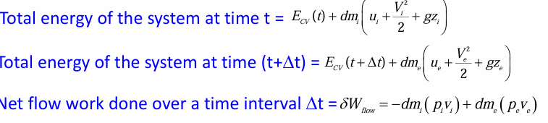
- 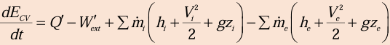
- Steady flow devices: 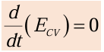
These relations are for steady flow devices with single inlet and outlet. We may similarly write for multiple inlet/exit cases.
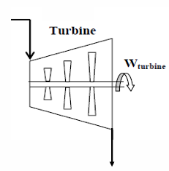
- Steam/Gas Turbine: Heat transfer is usually neglected, Changes in potential energy may be less important, Many times changes in kinetic energy may be neglected.
- Heat Exchanger: No external work is done in the device and KE as well as PE changes are negligible.
If multiple inlets and outlets then No exchange of heat between the control volume and the surrounding.
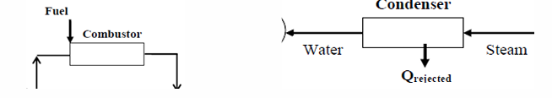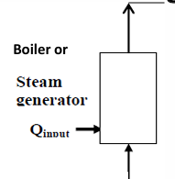
- Water pump: No heat transfer, Liquid is almost incompressible (pressure is constant) and change in specific volume is negligible, Change in temperature may be negligible, Often, a change in KE and PE may be neglected.
- Compressor: Heat transfer is usually neglected, Changes in potential energy may be less important, Many times changes in kinetic energy may be neglected.
- Vapour compression Refrigeration Cycle: This device is used to control flow rates in pipelines and other flow equipment. There are no heat and work interactions and KE as well as PE changes are assumed to be negligible. 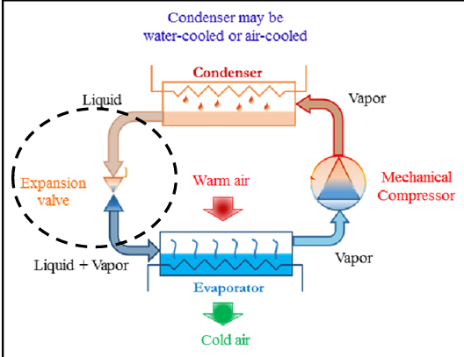
- Flow Nozzles and Diffusers: Conservation of mass: 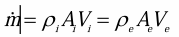
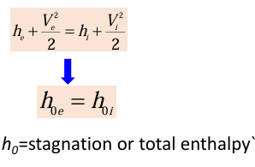
There are no heat and work interactions , PE changes are assumed to be negligible , KE changes cannot be ignored , Many times, a) In nozzle, inlet velocity << outlet velocity b) In diffuser, inlet velocity >> outlet velocity

